CSA1708-ARTIFICIAL INTELLIGENCE
LAB EXPERIMENTS
Program 22 : Prolog Program to Check Bird Flight
Aim
To use Prolog facts and rules to print whether a selected bird can fly.
Algorithm
1. Store facts for birds that can fly and birds that cannot fly.
2. Define a rule that prints a message for a flying bird.
3. Define another rule that prints a message for a flightless bird.
4. Query the program with a bird name to display its flight status.
Program
can_fly(sparrow).
can_fly(pigeon).
can_fly(eagle).
cannot_fly(penguin).
cannot_fly(ostrich).
bird_status(Bird) :-
can_fly(Bird),
format('~w can fly.~n', [Bird]).
bird_status(Bird) :-
cannot_fly(Bird),
format('~w cannot fly.~n', [Bird]).
Sample Input
?- bird_status(sparrow).
?- bird_status(penguin).
Program Execution
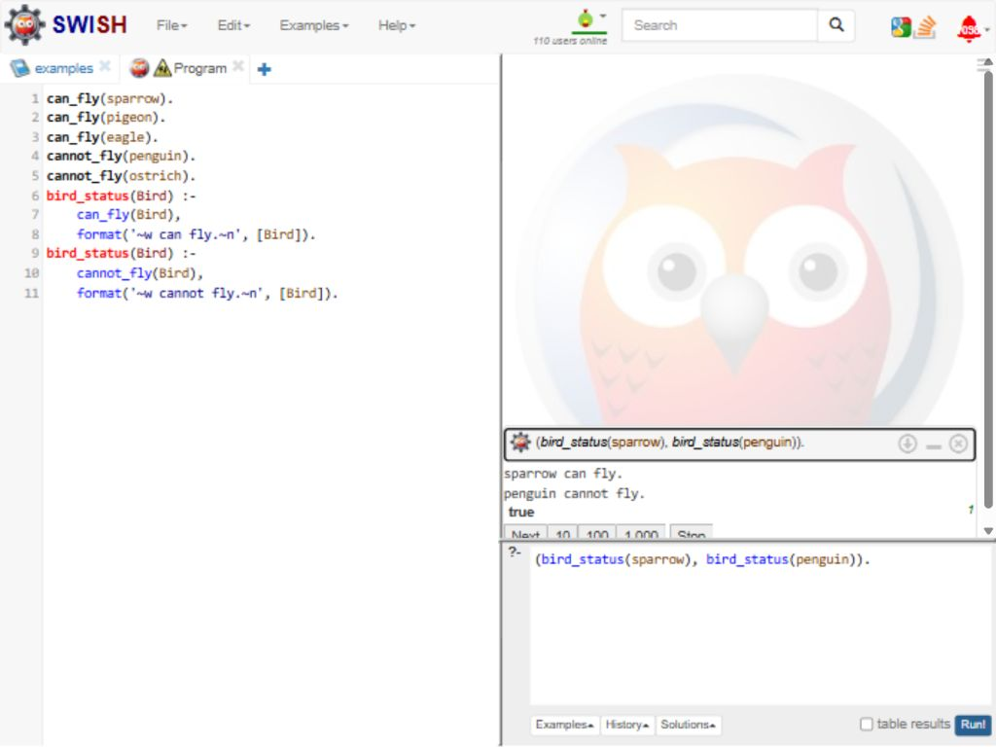
RESULT
Thus, the sample queries reported that sparrow can fly and penguin cannot fly according to the stored facts.

